NOTICE OF RACE
SNIPE CLASS INTERNATIONAL RACING ASSOCIATION

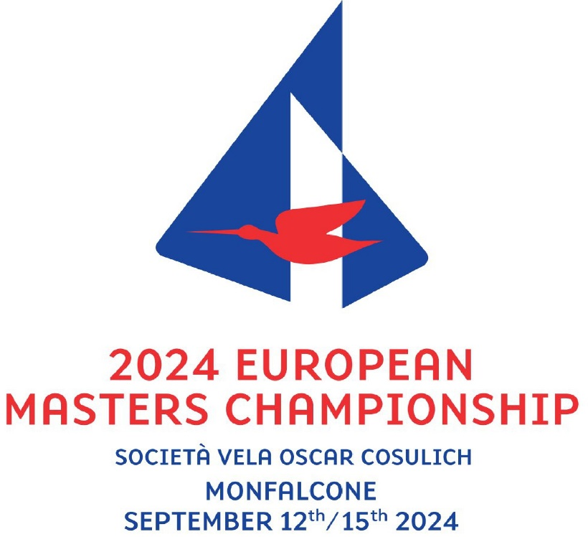

ORGANIZING AUTHORITY:
The regatta is organised by Società Vela Oscar Cosulich (SVOC) with the approval of Federazione Italiana Vela (FIV), and in cooperation with the Snipe Class International Racing Association (SCIRA) and the Snipe Class Italia.

[SP] denotes a rule for which a standard penalty may be applied by the Race Committee or technical committee without a hearing or a discretionary penalty applied by the International Jury with a hearing. (Changes rule RRS 63.1, A4 and A5).
[NP] denotes a rule that shall not be grounds for protests by a boat. (Changes RRS 60.1(a))

1 RULES
The regatta will be governed by:
1.1 The rules as defined in the Racing Rules of Sailing. (RRS)
1.2 The SCIRA Rules of Conduct for Conducting National and International Championship Regattas (RoC) available at https://www.snipe.org/images/2021/SCIRA_2021_Rules_of_Conduct_final.pdf
1.3 The Deed of Gift, available at
https://www.snipe.org/images/2021/European_Masters_Championship_2021-final.pdf.
1.4 The RRS 30.4, 32.1, 32.2, 33, 35, 64.3, A4 and A5 are changed, as specified in the Sailing Instructions according with SCIRA Rules of Conduct for Conducting National and International Championship Regattas (RoC).
1.5 This NoR, the Sailing Instructions and subsequent Official Communicates. In case of conflict between the Notice of Race and the Sailing Instructions, the latter will prevail, including subsequent Official Communicates. (This changes RRS 63.7).
1.6 RRS 90.3(e) will apply.
1.7 No national prescriptions will apply.
1.8 No drones are allowed closer than 500 m from racing areas from the Warning Signal for a race and after the last boat has finished the last race of the day. This does not apply to OA drones.
1.9 Appendix P will apply.
1.10 Rule 40 Personal Flotation Device applies at all times while afloat. (This changes RRS Preamble of Part 4)

2 SAILING INSTRUCTIONS
2.1 The sailing instructions will be available after 20:00h on September 6th at https://www.racingrulesofsailing.org/events/8948.

3 COMMUNICATION
3.1 The online official notice board (AUC) is located at https://www.racingrulesofsailing.org/events/8948.
3.2 All announcements and documents may be replicate, purely as a courtesy, on a specifically created Telegram or Whatsapp group, and on the website www.svoc.org
3.3 [DP] [NP]Except in an emergency or when using equipment provided by the Race Committee, a boat that is racing shall not make voice or data transmissions and shall not receive voice or data communication that is not available to all boats.

4 ELIGIBILITY AND ENTRY
4.1 This regatta is open to SCIRA registered boats for the current year, subject to any Deed of Gift restrictions.
4.2 Eligible boats may enter by completing the entry form and submitting it, together with the required fee, before 24:00h of August 30th,2024. Entries may be accepted after this date only with approval by the OA on a case-by-case basis by paying a registration fee increased by 50% as per FIV regulations.
4.3 Italian boats may enter the event by registering online at the FIV Website www.federvela.coninet.it. by logging in by their credentials. Non-italian competitors may enter the event by registering online at the link https://forms.gle/j8D6ADT68yU1X8K26
4.4 Only boats that have completed all registration requirements will be allowed to compete.
Note – completed registration includes payment of entry fee.
4.4 No crew shall be eligible to enter any Class championship race unless:
- they possess and present a current Class Membership Card, or
- SCIRA-issued equivalent, or
- shows as member in the SCIRA Official Online Database.
4.5 A skipper shall be designated in the entry form.
4.6 The designed skipper must be at the helm while racing except in the event of an emergency involving the safety of the boat or crew.
4.7 The skipper shall be 45 years old in the year of the event. The combined age of the team shall be minimum 80 years.
4.8 The following categories will be established:
APPRENTICE MASTER DIVISON (Skippers from 45 to 54 years)
MASTER DIVISION (Skippers from 55 to 64 years)
GRAND MASTER DIVISION (Skippers from 65 to 74 years)
MASTER LEGEND DIVISION (Skippers with 75 years or more)

5 FEES
5.1 The entry fee is €150,00
5.2 Payment by bank transfer will be made out to

Società Vela Oscar Cosulich
Banca di Credito Cooperativo Venezia Giulia
IBAN: IT19Q0887764611000000109661
Indicating in the reasons: name of the helmsman and the sail number of the boat
5.3 Registration must be completed by sending the following documents to the Regatta Secretery at sport@svoc.org :
- Membership of own National Federation
- Class Card valid for the current year
- Receipt of the registration fee
- Measurement certificate of the boat
- Policy and payment receipt for adeguate third-party liability insurance with minimum coveratge
- DNI, Passport or accreditive document of the age of each participant
5.4 To complete the registration, before 10.00h of September, 13th, each skipper must present to the Regatta Secretary the measurement form and stamping properly filled and approved by the technical committee.

6. SCHEDULE
6.1
Date | Hour | Action
Thursday, September 12th | 09:00h to 13:00h  and  14:00h to 19:00h | Registration of participants and coaches  Equipment control
Friday, September 13th | 09:00h to 11:00h  11:00h  11:30h  13:00 h | Registration of participants and coaches Equipment control  Opening cerimony  Skippers team leaders and coaches meeting  Races
Saturday, September 14th | TBD | Races
Sunday, September 15th | TBD  After racing | Races  Price giving

6.2 The scheduled time for the display of the first warning signal on Saturday and Sunday will be posted on the AUC by 20:00h of the previous day. In the absence of this announcement, the time of display of the warning signal will be that of the previous day.
6.3 On Sunday, Septemer 15th no warning signal will be made after 16:00h.
6.4 When the entrants exceed 75 boats, the fleet may be split, and the regatta will consist of a qualifying series and a final series.

7 EQUIPMENT INSPECTION
7.1 [DP] Initial Equipment Inspection: All boats shall be presented for inspection with the full equipment, including sails and personal flotation devices during the scheduled measurement. Boats and equipment shall be presented in a dry, clean, and salt-free condition. The Technical Committee or Race Committee may extend the Initial Equipment Inspection time.
7.2 All boats will be weighed and all sails will be stamped only. Competitors shall present a maximum of 2 suits of sails which will have been previosly measured.
7.3 The measurement certificate should be presented during the initial equipment inspection. (Changes RRS rule 78.2)
7.4 A boat or equipment may be inspected at any time for compliance with the class rules, notice of race and sailing instructions.
7.5 [DP] When instructed by a race official on the water, a boat shall proceed to a designated area for inspection.

8 ADVERTISING
8.1 According to Regulation 20 World Sailing (Advertising Code) the regatta is classified as “unrestricted advertising” (Olympic class). Competitors whose boats display advertising must present a valid FIV license at the time of registration.
8.2 Boats may be requested to display advertising chosen and supplied by the organizing authority.

9 VENUE
9.1 Races will be sailed in the Gulf of Panzano

10 COURSES
10.1 The courses to be sailed are the Class approved courses as published in the SCIRA web site.

11 SCORING
11.1 6 races are scheduled. 3 races are required to be completed to constitute a series.
11.2 (a) When fewer than 5 races have been completed, a boat’s series score will be the total of her race scores.
(b) When from 5 to 6 races have been completed, a boat’s series score will be the total of her race scores excluding her worst score.

12 SUPPORT PERSON VESSELS
12.1 Between the preparatory signal and the starting signal, Support Vessels must be positioned at least 50 meters below the starting line. After the starting signal Support Vessels may follow the fleet, but only on the port side of the course and must stay 50 meters from any mark.
12.2 Support Persons shall register at the Regatta Office and all support boats shall be identified by a white flag with letter S

13 DATA PROTECTION AND RIGHTS TO USE NAME AND LIKENESS
13.1 By participating in this event, competitors automatically grant to SCIRA, the organizing authority and the event sponsors the right, in perpetuity, to make, use, and show, at their discretion, any photography, audio and video recording, and other reproductions of them made at the venue or on the water from the time of their arrival at the venue, until their final departure, without compensation.
13.2 By participating in the 2024 Snipe Masters European Championship competitors agree to receive event information from the event Organising Authorities.
13.3 Boats may be required to carry cameras or GPS positioning equipment as specified by the Organising Authority. Competitors may be required for interviews at the regatta.

14 RISK STATEMENT
14.1 RRS 3 states: "The responsibility for a boat's decision to participate in a race or to remain in a race rests solely with it." Therefore, participants are aware that sailing falls within the scope of Article 2050 of the Italian Civil Code and that all participants must have a valid federal membership guaranteeing accident coverage, including death and permanent disability. Foreign competitors must comply with any requirements of their MNA and be in possession of accident cover including death and permanent disability, as per current FIV regulations.
14.2 The OA, The Committees or any person or organization involved in the organisation of the event denies any responsibility because of looseness damage or injury or bother that could happen to persons or things ashore or at the sea as a consequence of the participation of the races under this Notice of Race

15 INSURANCE
15.1 Each participating boat shall be insured with valid third-party liability insurance with a minimum cover of €1500000,00 per incident or the equivalent.

16 PRIZES
16.1 Trophies will be given for the three first classified of each category and the title of 2024 Snipe European Master Champion to the winner of the Championship.
16.2 The following categories will be established:
Apprentice Master Division (45 – 54 years old)
Master Division (55 – 64 years old)
Grand Master Division (65 – 74 years old)
Master Legend Division (75 years old and over)

17 ENVIRONMENTAL RESPONSIBILITY [DP] [NP]
17.1 Recalling the Basic Principle which states: "Participants are encouraged to minimize any negative environmental impact of the sport of sailing," it is recommended that care be taken to protect the environment at all times before, during and after the event. In particular, attention is drawn to RRS 47 -Waste Disposal- which states: "Competitors and support persons shall not deliberately litter the water. This rule applies at all times when in the water. The penalty for an infraction of this rule may be less than disqualification".

18 CODE OF CONDUCT [DP]
18.1 Competitors and support persons shall comply with any reasonable request from an event official. Failure to comply may be misconduct.
18.2 Competitors shall handle any boats or equipment provided by the organizing authority with proper care and seamanship and in compliance with any written instructions.

19 FURTHER INFORMATION
18.1 For further information please contact sport@svoc.org or segreteria@svoc.org

20 SCIRA REPRESENTATIVE
The SCIRA representative will be communicated.

21 SOCIAL EVENTS
The social events will be announced on the club’s website www.svoc.org.

